**Ideation Phase**

**Empathize & Discover**

|  |  |
| --- | --- |
| Date | 26.06.2025 |
| Team ID | SWUID20250170870 |
| Project Name | Freelancing Application Mern |
| Maximum Marks | 4 Marks |

**Empathy Map Canvas:**

Understand the needs, frustrations, and behaviors of users who want a clean, friendly, and meaningful social media experience.

For freelancing application project, the overall it has sections like:

✅ Think & Feel ✅ Say & Do ✅ See & Hear ✅ Pains & Gains)

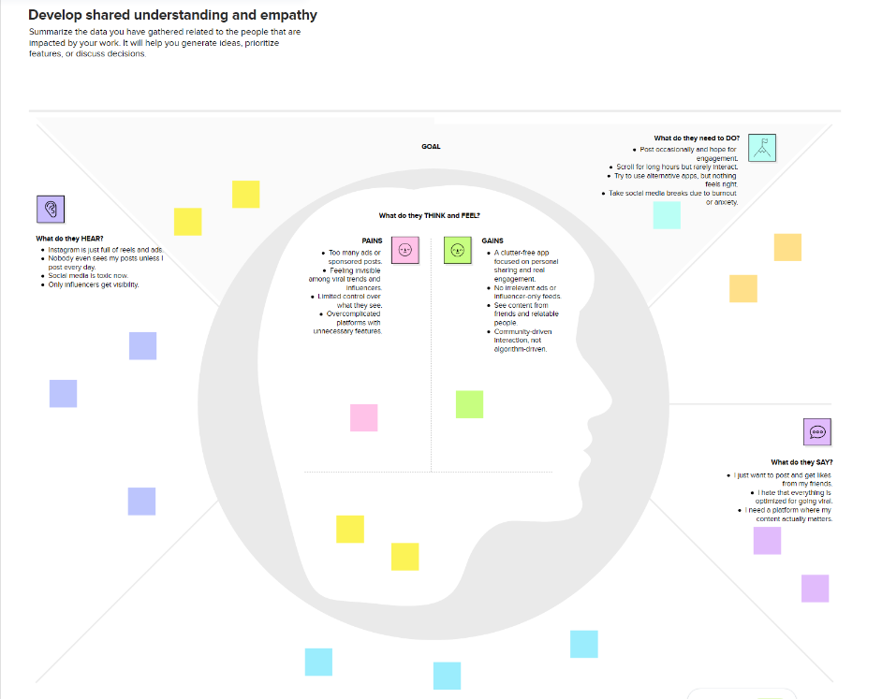

Reference: <https://www.mural.co/templates/empathy-map-canvas>